| **Test Name** | | It is possible to charge a room for service after the guest has checked out. | | | |
| --- | --- | --- | --- | --- | --- |
| **Use Case Tested:** | | Check out Service | | | |
| **Test Description:** | | This test script tests the known bug in the Check Out use case of Hotel Management System. This test is performed to check whether reported bug of possible to charge a room for service after the guest has checked out is present and replicable. | | | |
| **Pre-conditions** | | The Hotel Management System application must be running, and the user must proceed book room, check in, record service and check out before trying to charge the room. | | | |
| **Post-conditions** | | Service cannot be added to checked out room. | | | |
| **Notes:** | | As described in Pre-condition, user must follow book room, check in, record service and check out before trying to charge a room for service after the guest has checked out. So, test data table will show all the values that was provided to replicate the error. | | | |
| **Result (Pass/Fail/Warning/Incomplete)** | | Fail, the bug was replicated during test. | | | |
|  | **TEST STEP** | | **EXPECTED TEST RESULTS** | P | F |
|  | User choose Book a Room from menu and create a booking. | | Room is booked for user with information in test table. | P |  |
|  | User choose Check in a Room from menu and check in. | | User was able to check in to the room. | P |  |
|  | User choose Register service and add Restaurant and Room Service of 300 and 200 cost respectively. | | Charges were shown to be added with visual text. | P |  |
|  | User choose Check out and continue to pay service charge and check out. | | All the cost incur during the stay was presented and user was able to check out successfully. |  | F |
|  | User choose record service | | User should not be able to add service charge to checked out room. |  | F |

|  |  |  |  |  |
| --- | --- | --- | --- | --- |
|  | **Test Data Table** | | | |
|  |  | **1** | **2** | **3** |
| 1. Book Room | Main Menu | B | B | B |
| Enter phone number | 123 | 321 | 111 |
| Enter guest name | Bikram | Romeo | Chitra |
| Enter guest address | 12 Home | 12 Hotel | 21 Home |
| Enter room type selection | D | S | D |
| Enter number of occupants | 2 | 1 | 2 |
| Arrival Day: Enter day(dd) | 27 | 27 | 27 |
| Enter month (mm) | 09 | 09 | 09 |
| Enter year () | 2018 | 2018 | 2018 |
| Enter length of stay | 2 | 1 | 2 |
| Enter credit card type selection | M | V | V |
| Enter credit card number | 1 | 2 | 1 |
| Enter CCV | 1 | 2 | 1 |
| Hit <enter> to continue | ENTER< | ENTER< | ENTER< |
| 1. Check in | Main Menu | C | C | C |
| Enter confirmation number | 2782018201 | 2782018101 | 2782018201 |
| Confirm check-n? (Y/N) | Y | Y | Y |
| Hit <enter> to continue | ENTER< | ENTER< | ENTER< |
| 1. Record Service | Main Menu | R | R | R |
| Enter Room Id | 201 | 101 | 201 |
| Enter service type | R | B | R |
| Enter cost | 300 | 200 | 200 |
| Hit <enter> to continue | ENTER< | ENTER< | ENTER< |
| 1. Check out | Main Menu | D | D | D |
| Enter room number | 201 | 101 | 201 |
| Accept charges(Y/N) | Y | Y | Y |
| Enter credit card type selection | M | V | V |
| Enter credit card number | 1 | 1 | 1 |
| Enter CCV | 1 | 1 | 1 |
| Hit <enter> to continue | ENTER< | ENTER< | ENTER< |
| 1. Record Service | Main Menu | R | S | R |
| Enter Room Id | 201 | 101 | 201 |
| Enter service type | S | S | R |
| Enter cost | 200 | 200 | 50 |
| Hit <enter> to continue | ENTER< | ENTER< | ENTER< |

# Screenshot of Bugs.

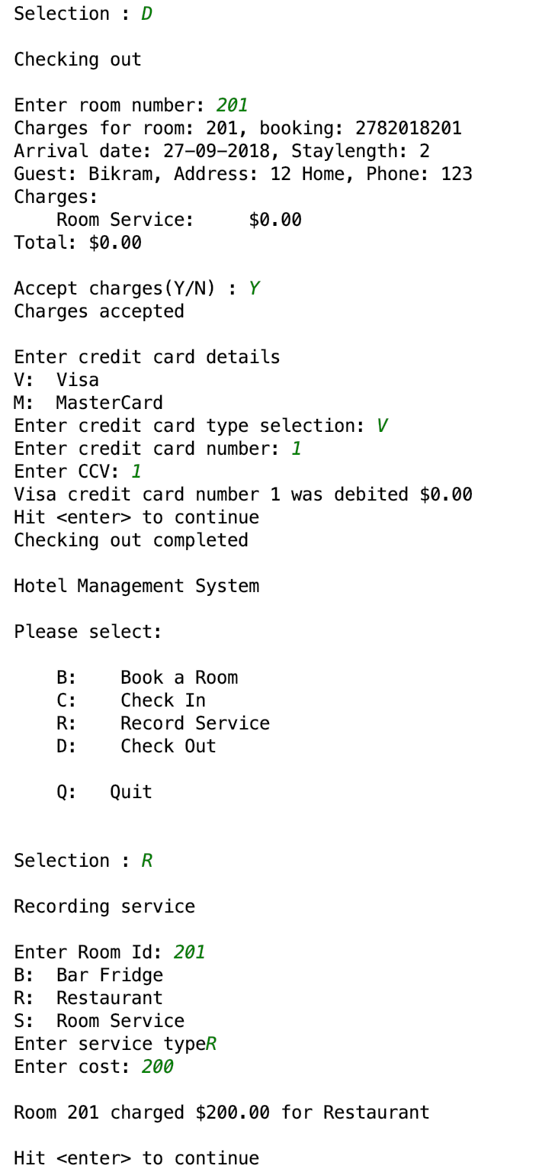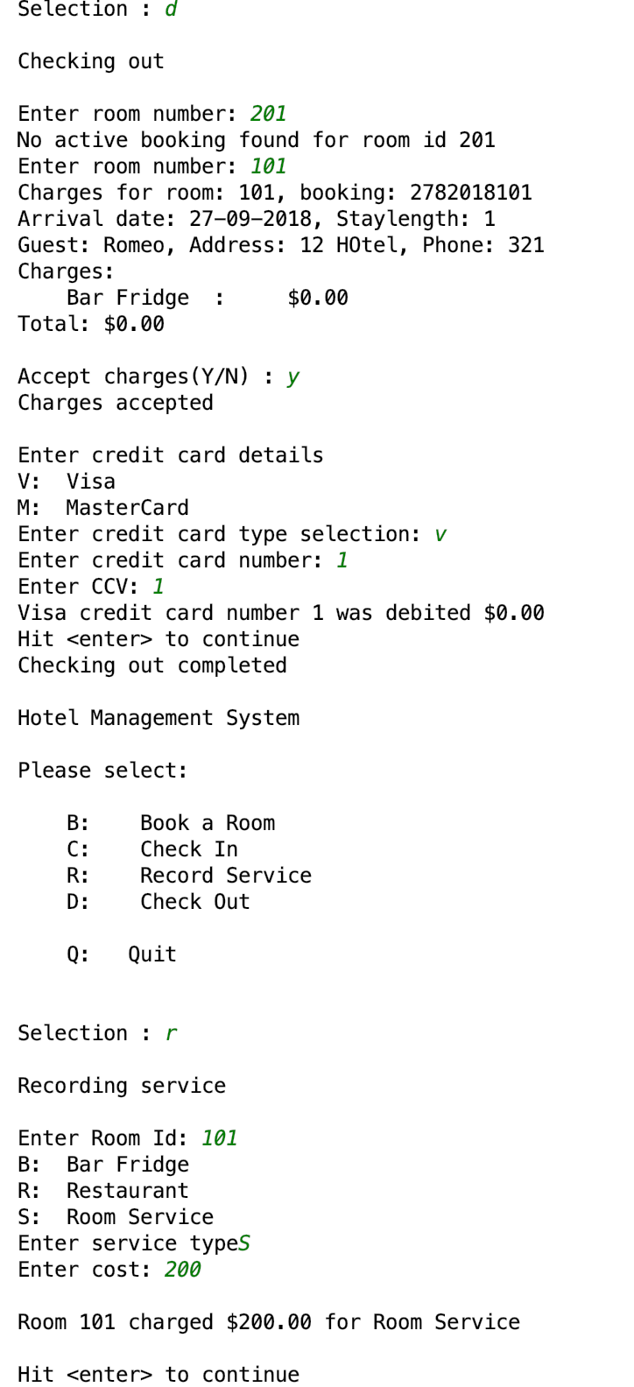

Figure: Test data 1 and data 2 output showing bug.

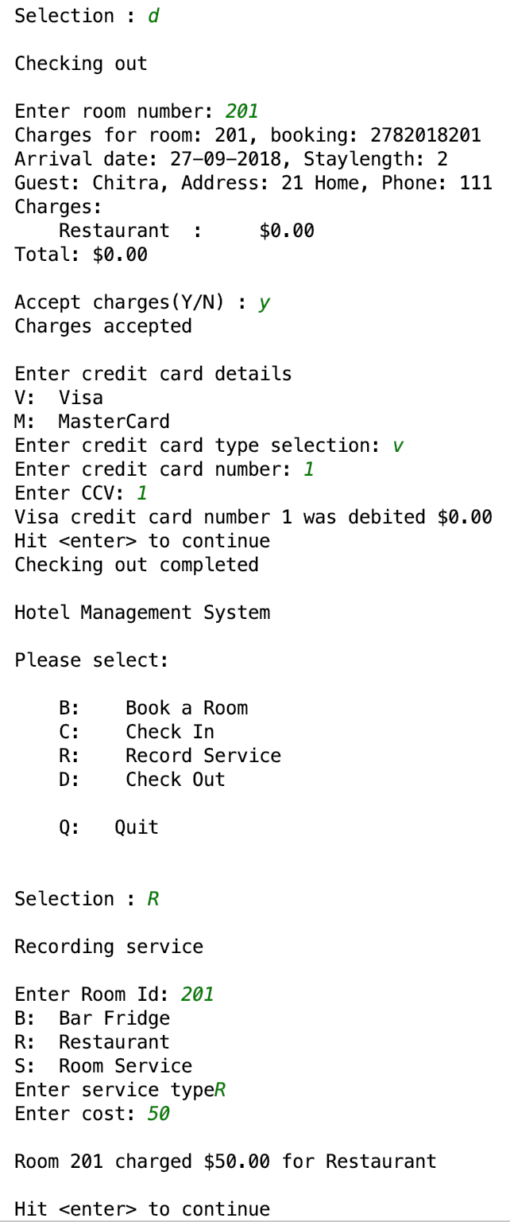

Figure: Test data 3 output showing bug.